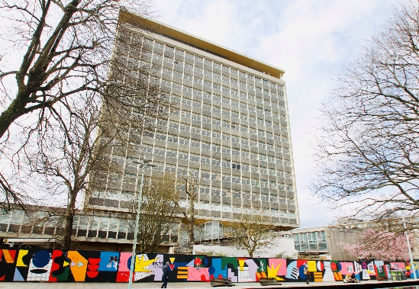 | 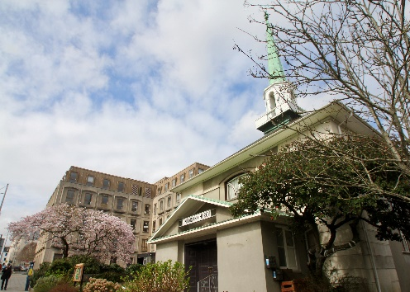 | 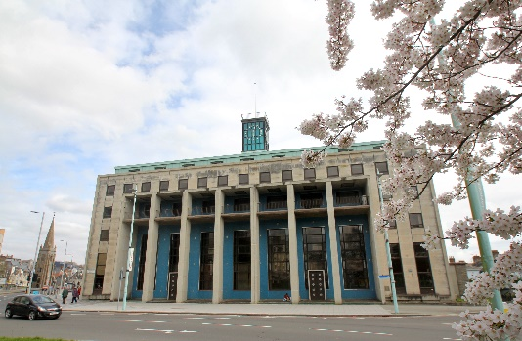

HIGH STREET SPARKS
Small Grants Scheme
The £95 million government-funded High Streets Heritage Action Zone programme, delivered by Historic England, will unlock the potential of high streets across England, fuelling economic, social and cultural recovery and breathe new life into it for future generations. 60 high streets have been offered funding to give them a new lease of life including the conservation area in Plymouth’s city centre.
Plymouth’s city centre is unique. After its high street was razed to the ground during the Second World War, Plymouth took the brave decision to completely re-build its centre with modern buildings on broad new boulevards. Though some are now tired, many of these buildings incorporate beautiful detailing and artworks with richly differing architectural styles. Just as York is famous for its medieval city and Bath for its regency architecture, Plymouth deserves its place in our national story as the country’s finest and boldest post-war city centre.
The Plymouth City Centre High Street Heritage Action Zone (HSHAZ) programme – ‘reinvigorating the Abercrombie Estate’ – is a four-year programme about celebrating, enhancing and adapting the city centre’s post-war heritage and making it a more attractive, engaging and vibrant place for people to live, work and spend time.

Over the next three years Plymouth’s HSHAZ will fund projects that respond to our city centre and its wonderful heritage. This engagement work is managed by The Box, POP and Plymouth City Council.

Small grants of up to £2,500 will be gifted to community projects which breathe life back into our city centre (£5,000 in exceptional circumstances). We are particularly interested in work that focuses on the conservation area but will also welcome projects that tie in the wider Plan for Plymouth.

Projects that apply for funding will have to include at least one of the values associated with the HSHAZ work. These include:

HERITAGE – help local people understand, appreciate and celebrate the heritage of our high street within the conservation area through producing memorable experiences.

DIVERSITY – increase the variety of activities on offer in our high Street/conservation area. Provide a space for diverse communities.

FOOTFALL – help attract people to our high street/conservation area.

SAFE SPACE – help provide a safe space for people to enjoy our high street/conservation area.

Who are you?
Community group (the name of your group)
Community members (spokesperson for your group)
Individual

What project would you like the money for and why?
Click or tap here to enter text.

Who will benefit from this project or activity?
Click or tap here to enter text.

How many people will benefit from this activity?
Click or tap here to enter text.

Where will the activity take place?
Click or tap here to enter text.

How much money would you like and how are you going to spend it?
Click or tap here to enter text.
Contact details

Who is the main contact for this application?
Address: ________________________________________________________________________________________________________________________________________________________________________________________________________________________________________________________

Phone number/mobile: ______________________________________________________________

Email address:
______________________________________________________________

Please note: High Street Sparks does not fund:

- Activities that take place outside Plymouth
- Retrospective grant aid for work already completed or which will have started before the application is considered
- Publicity campaigns
- Projects whose prime aim is to redistribute earned income from the proposal to other good causes including charitable appeals and organisations
- Commercially-run projects

The deadline for this round of High Street Sparks applications is MIDNIGHT ON 30 SEPTEMBER 2021. Please email your completed application to fiona.evans@plymouth.gov.uk.
The High Streets Heritage Action Zone initiative is funded with £40 million from the Department for Digital, Culture Media and Sport’s Heritage High Street Fund and £52 million from the Ministry of Housing, Communities and Local Government’s Future High Street Fund. A further £3 million will be provided by the National Lottery Heritage Fund to support a cultural programme.

